**Experiment: 1**

**Aim:** Write a Java Program to implement all types of Inheritance.

**Software:** VS Code

**Code:-**

// Write a Java Program to implement all types of Inheritance.

import java.util.*;

class Parent_Class

{

    int num1;

    int num2;

    public void Add(int num1,int num2)

    {

        this.num1 = num1 ;

        this.num2 = num2 ;

        System.out.println("This Is A Method Of Patent Class");

        System.out.println("The Addition Of " + this.num1 + " and " + this.num2 + " Is " + (this.num1 + this.num2));

    }

}

class Child_Class_1 extends  Parent_Class

{

    int num3;

    public void Add(int num1,int num2,int num3)

    {

        this.num1 = num1;

        this.num2 = num2 ;

        this.num3 = num3 ;

        System.out.println("This Is A Method Of Child Class-1");

        System.out.println("The Addition Of " + this.num1 + " , " + this.num2 + "and " + this.num3 + " Is " + (this.num1 + this.num2 + this.num3));

    }

}

class Child_Class_2 extends  Parent_Class

{

    int num4;

    public void Add(int num1,int num2,int num4)

    {

        this.num1 = num1 ;

        this.num2 = num2 ;

        this.num4 = num4 ;

        System.out.println("This Is A Method Of Child Class-2");

        System.out.println("The Addition Of " + this.num1 + " , " + this.num2 + "and " + this.num4 + " Is " + (this.num1 + this.num2 + this.num4));

    }

}

class Grand_Child extends Child_Class_1

{

    int num5;

    public void Add (int num1 , int num2 , int num3 , int num5)

    {

        System.out.println("This Is A Method Of Grand Child Class:-");

        System.out.println("The Addition Of " + this.num1 + " , " + this.num2 + "and " + this.num3 + " , "+ this.num5 + "" + " Is " + (this.num1 + this.num2 + this.num3 + this.num5));

    }

}

public class Programm_1

{

    public static void main(String[] args)

    {

        Scanner sc = new Scanner(System.in) ;

        Parent_Class P = new Parent_Class();

        Child_Class_1 C1 = new Child_Class_1();

        Child_Class_2 C2 = new Child_Class_2() ;

        Grand_Child G = new Grand_Child();

        System.out.print("Enter The Number-1:-");

        P.num1 = sc.nextInt();

        System.out.print("Enter The Number-2:-");

        P.num2 = sc.nextInt() ;

        System.out.print("Enter The Number-3:-");

        C1.num3 = sc.nextInt() ;

        C1.num1 =  P.num1 ;

        C1.num2 =  P.num2 ;

        System.out.print("Enter The Number-4:-");

        C2.num4 = sc.nextInt() ;

        C2.num1 =  P.num1 ;

        C2.num2 =  P.num2 ;

        System.out.print("Enter The Number-5:-");

        G.num5 = sc.nextInt() ;

        G.num3 = C1.num3 ;

        G.num1 = P.num1 ;

        G.num2 = P.num2 ;

        P.Add(P.num1, P.num2);

        C1.Add(C1.num1, C1.num2, C1.num3);

        C1.Add(C1.num1, C1.num2);

        C2.Add(C2.num1, C2.num2, C2.num4);

        C2.Add(C2.num1, C2.num2);

        G.Add(G.num1, G.num2);

        G.Add(G.num1, G.num2, G.num3);

        G.Add(G.num1, G.num2, G.num3, G.num5);

        sc.close();

    }

}

**Output:**

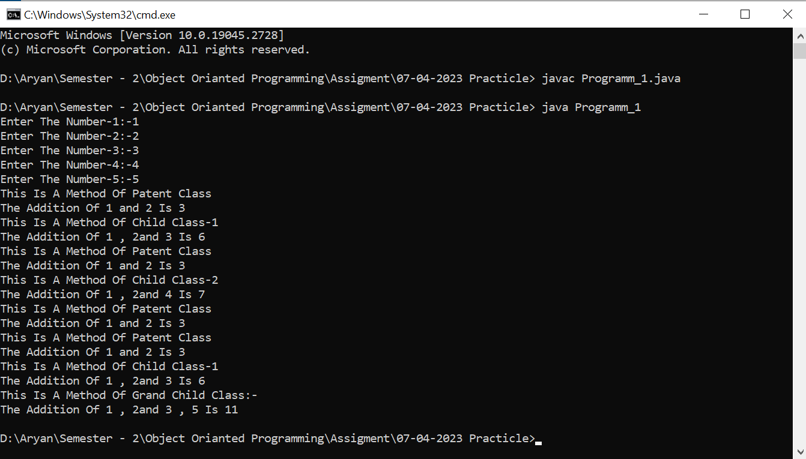

**Experiment: 2**

**Aim:** Write a Java Program to Implement Static method.

**Software:** VS Code

**Code:**

//  Write a Java Program to Implement Static method.

import java.util.*;

class LCM

{

    public static int cal(int num1,int num2)

    {

        if(num2 == 0)

        {

            return num1 ;

        }

        else

        {

            return cal(num2,num1%num2) ;

        }

    }

}

public class Programm_2

{

    public static void main(String[] args)

    {

        Scanner sc = new Scanner(System.in) ;

       int num1 ,num2 ;

        System.out.print("Enter The First Number:-");

        num1 = sc.nextInt();

        System.out.print("Enter The Second Number:-");

        num2 = sc.nextInt() ;

        int Add = (num1 * num2) / (LCM.cal(num1,num2) ) ;

        System.out.println("The LCM Of " + num1 + " and " + num2 + " Is " + Add);

        sc.close();

    }

}

**Output:**

